Voucher video photos

Halicitid bee: LO1 50:20

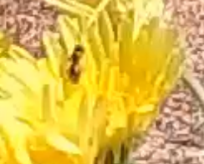11

10:57 vid 2 LO1

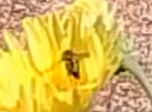

Eupodes?

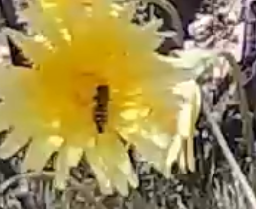

LS1 – 17:20 – Day 1